
ICP Final Project Report

Project Title:
Nest & Nook – Furniture Online Shop

Student 1 Details
Name: Kobra Nasiri
ID: 222073
AUW Email: kobra.nasiri@auw.edu.bd
Student 2 Details
Name: Khatira Akhlaqi
ID:232080
AUW Email: auw232080@auw.edu.bd
Student 3 Details
Name: Tasmin Ara
ID: 223036
AUW Email: tasmin.ara2022@auw.edu.bd
Submission Date: 12/AUG/2026

1. Abstract
Nest & Nook is a furniture online shop webpage designed to provide a simple and attractive way for users to explore furniture for different parts of a home. The website presents furniture products, room categories, a search area, a shopping cart interface, a newsletter section, and useful footer links.
The main products shown are Soft Sofa, Wood Chair, and Round Table. Users can also explore Living Room, Bedroom, Dining Room, and Office categories. The project was developed with HTML and is connected to separate CSS and JavaScript files. The main goal was to create a clean and easy-to-understand furniture shopping webpage.
2. Introduction
Furniture is an important part of a home, and an online furniture store can help users explore different products in one place. For this project, I created Nest & Nook, a furniture shopping webpage with the slogan “Comfort for Every Corner.”
The main objective was to build a simple furniture website that looks organized and provides the basic sections expected from an online furniture store.
Objectives
- Creating a furniture online shop webpage.
- Organizing furniture products clearly.
- Providing navigation and a furniture search area.
- Allowing users to browse furniture by room.
- Including a shopping cart interface and Add to Cart buttons.
- Practicing combining HTML, CSS, and JavaScript in one project.
3. Methodology / Implementation
The webpage was planned as several connected sections. HTML was used to create the structure, while the project links to a separate CSS file for styling and a separate JavaScript file for webpage interactions.
Header and Navigation
The header contains the Nest & Nook logo, website name, slogan, navigation links, search box, and shopping cart button. The navigation contains Home, Shop, Living Room, Bedroom, and Contact.
Hero Section
The hero section introduces the website with the message “Create Your Perfect Home.” It describes the furniture as modern, comfortable, and stylish and includes a Shop Now button.
Featured Products
The Featured Products section displays Soft Sofa ($499.00), Wood Chair ($199.00), and Round Table ($299.00). Each product includes an image, name, price, and Add to Cart button.
Shop by Room
The Shop by Room section includes Living Room, Bedroom, Dining Room, and Office. Each category has an image and a room name.
Newsletter and Footer
The newsletter section contains an email input and Subscribe button. The footer contains brand information, quick links, customer service links, and social media icons.
4. Results / Output
The final output is a complete furniture store webpage with a clear visual structure. It includes the main store navigation, product display, room categories, shopping-related interface, newsletter form, and footer.
The guideline requires visuals of code, input, and output. Insert the actual screenshots in the spaces below before submission.
MAIN HTML
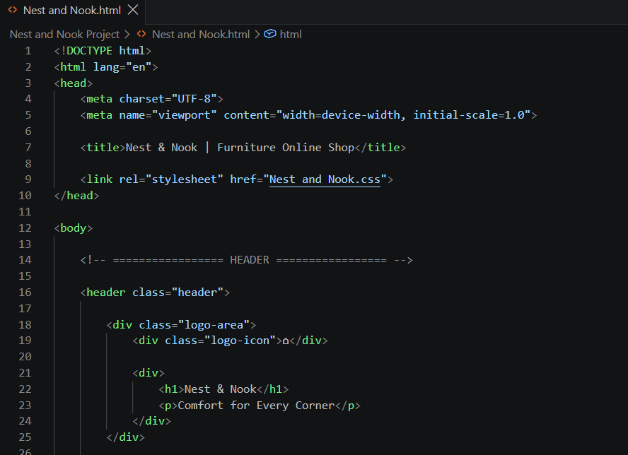
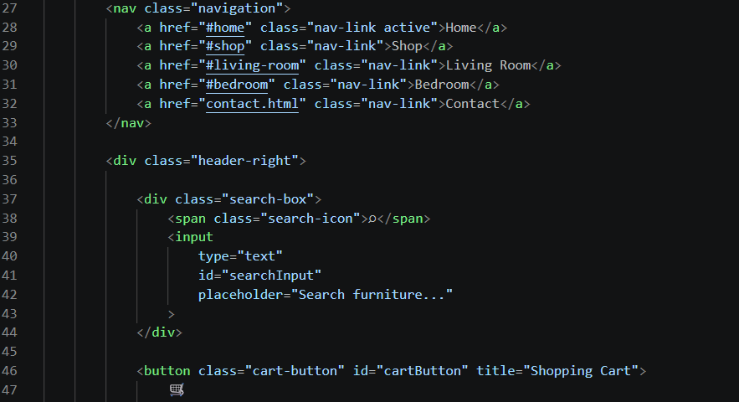
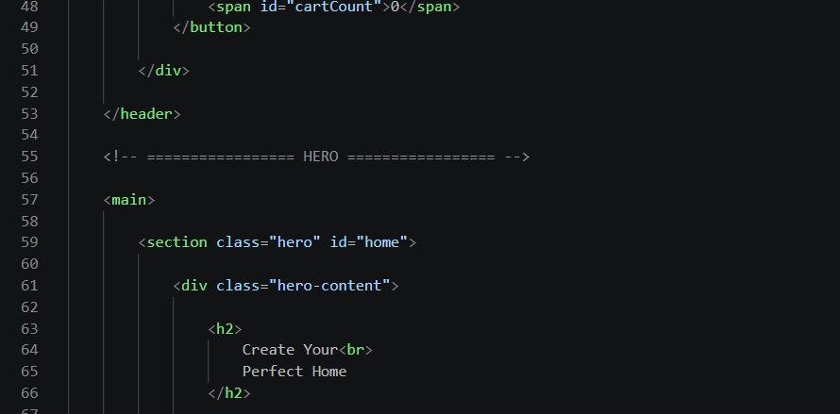
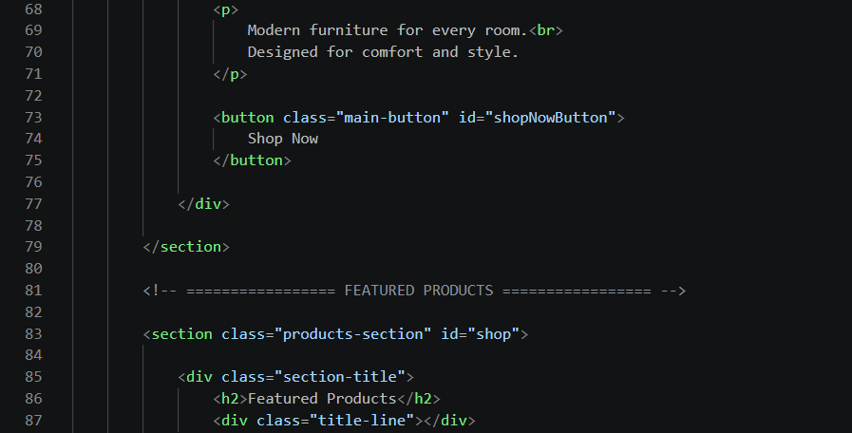
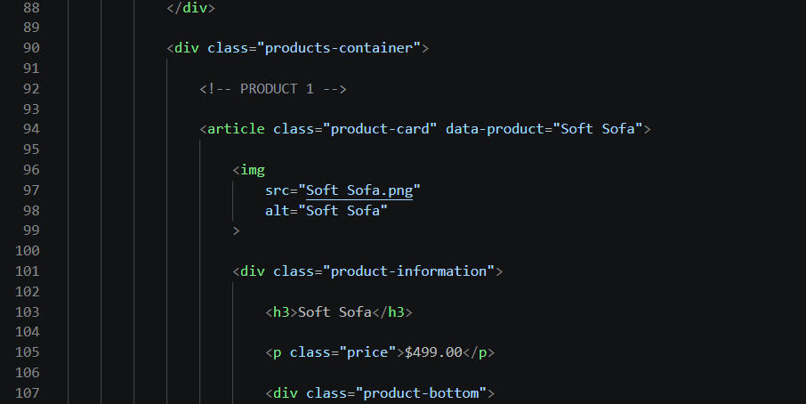
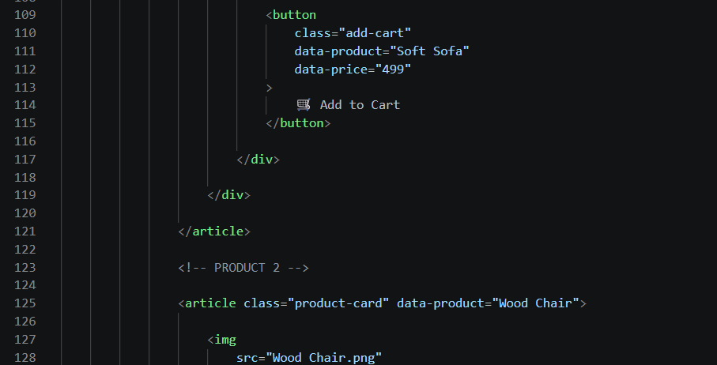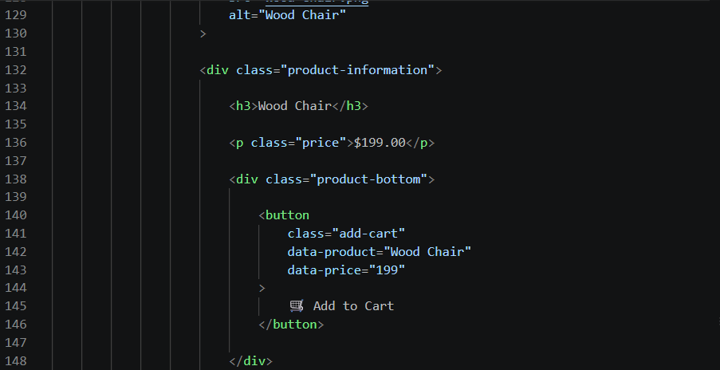
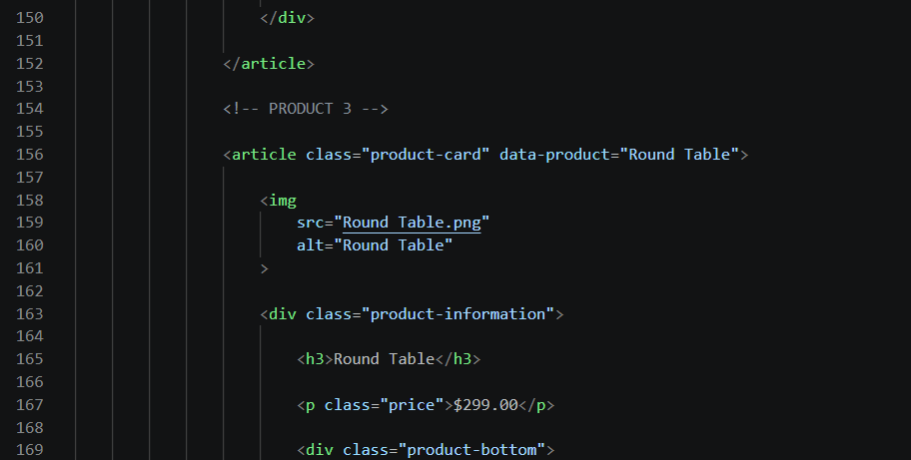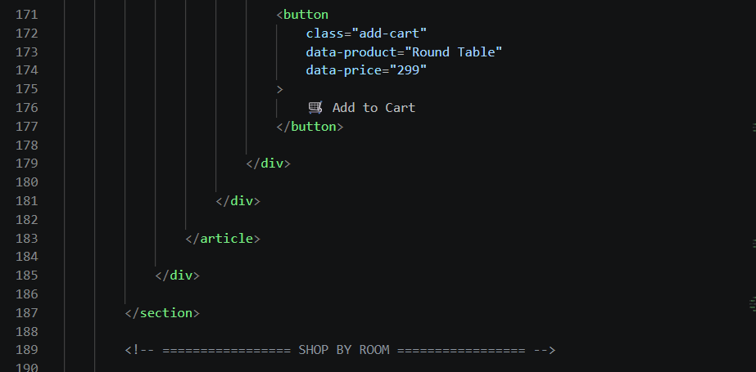
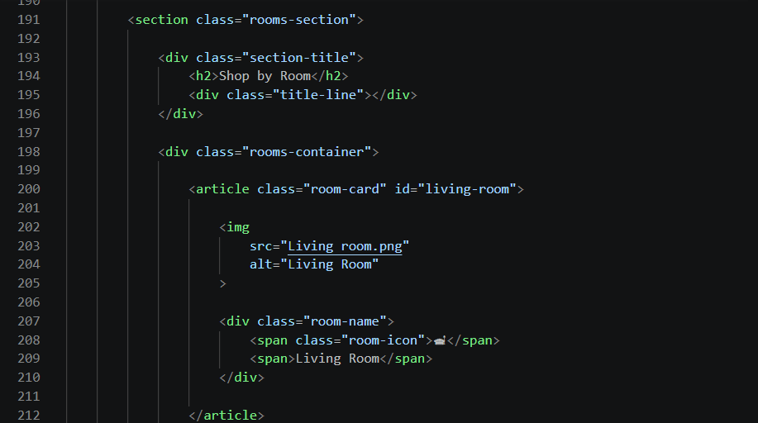
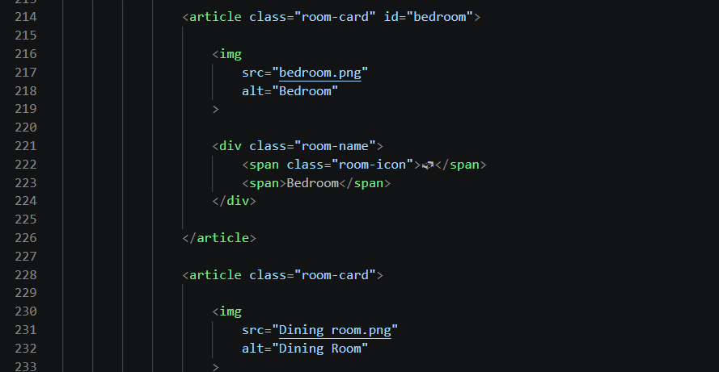
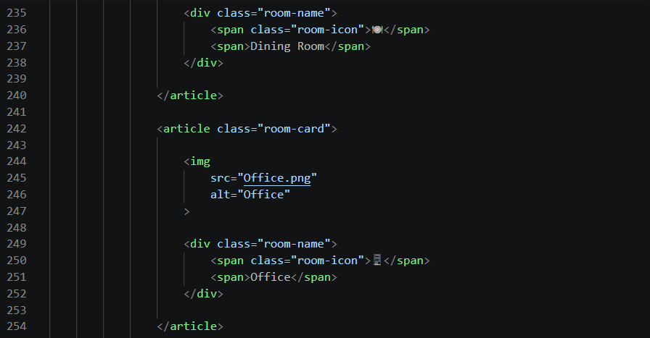
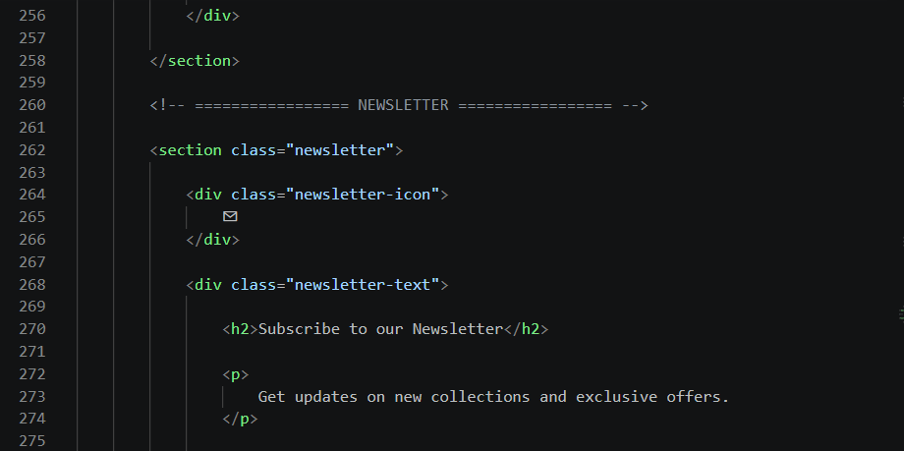
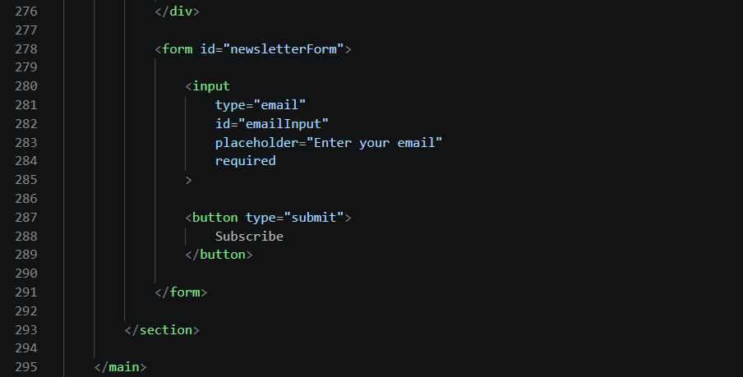
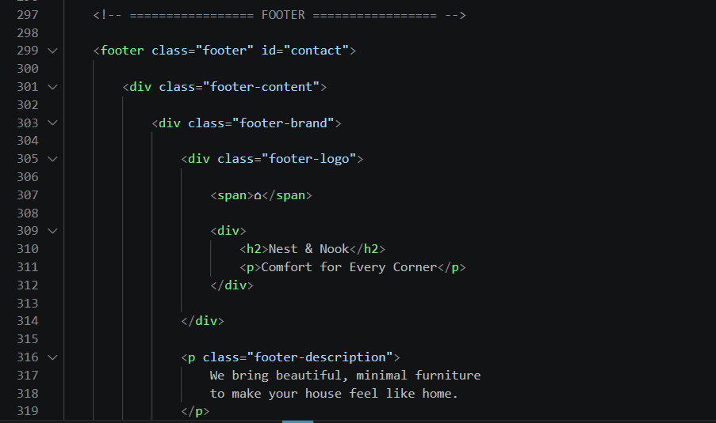
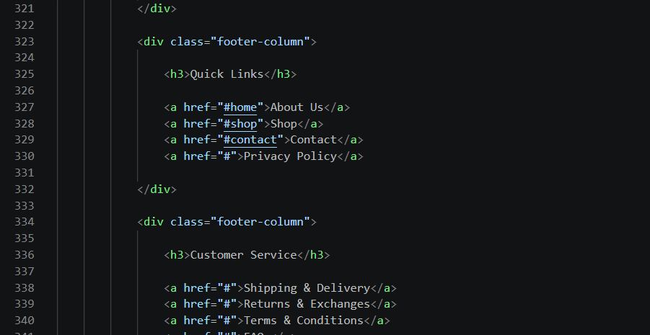

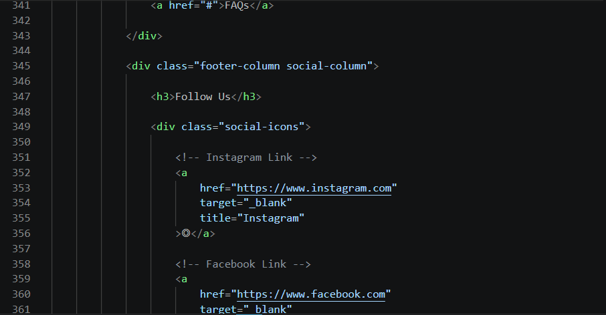
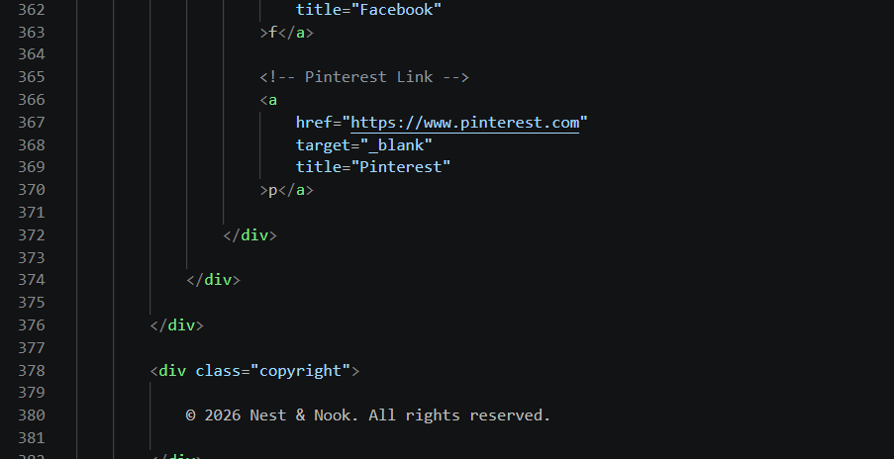
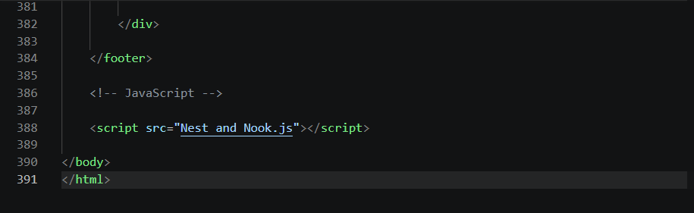

MAIN JS.

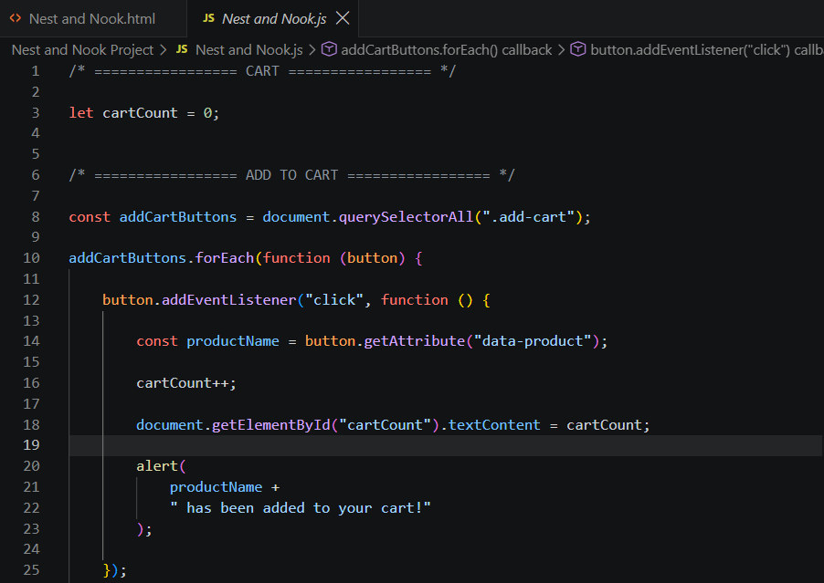
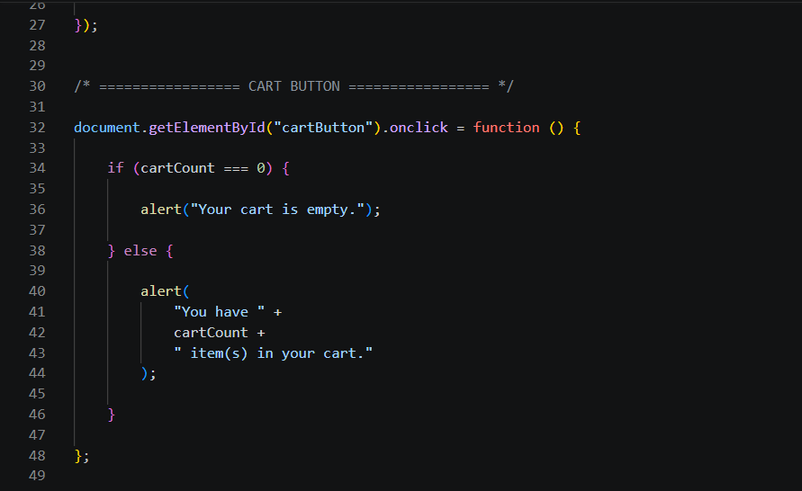
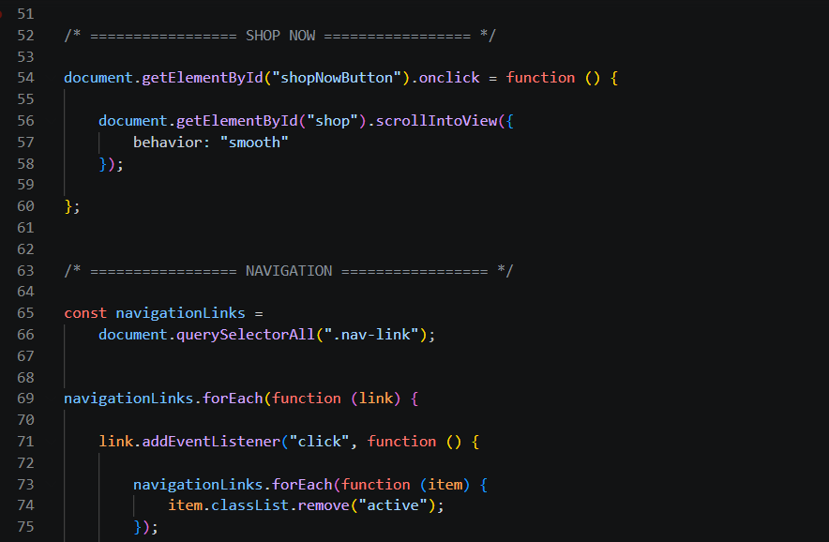
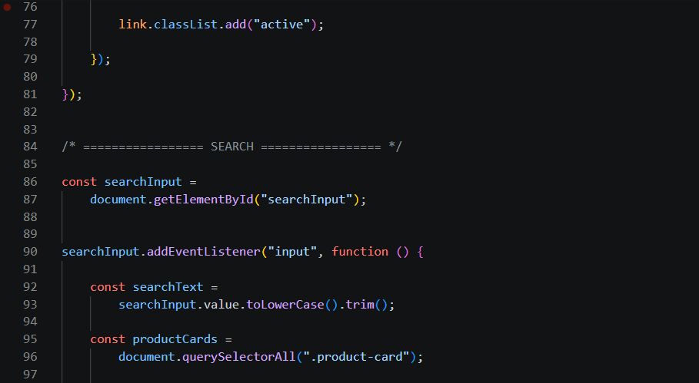
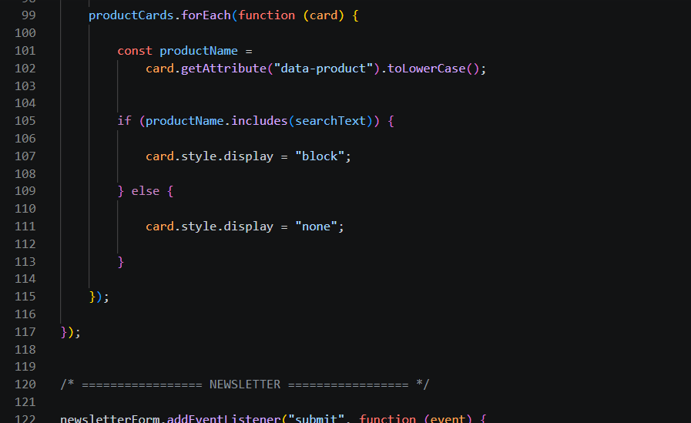
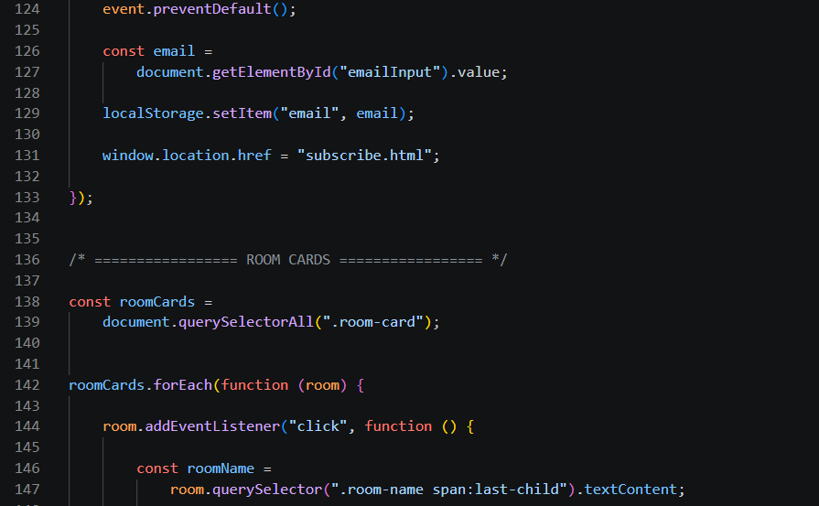

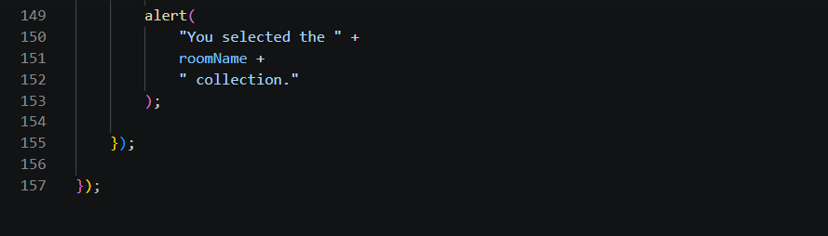

CONTACT HTML

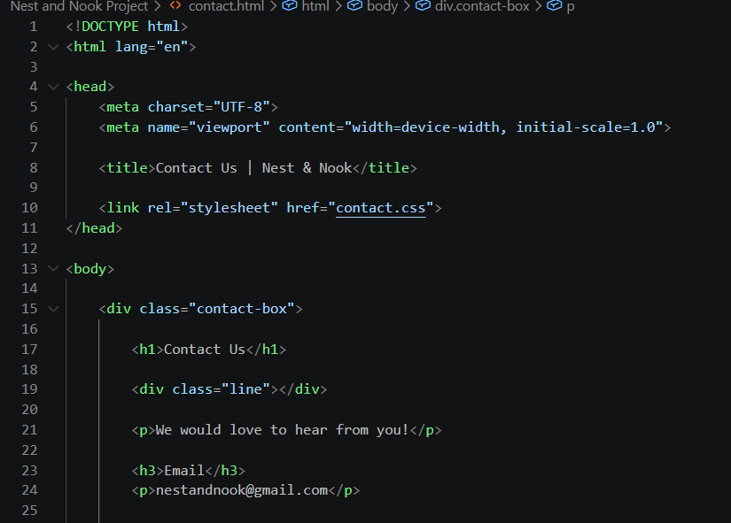
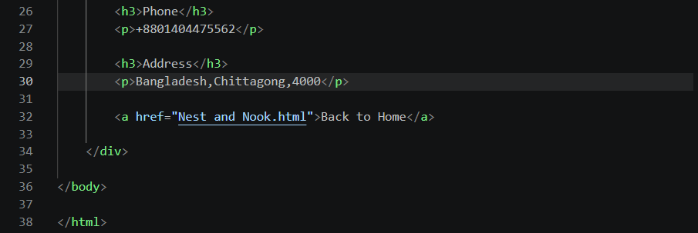

SUBSCRIBE HTML

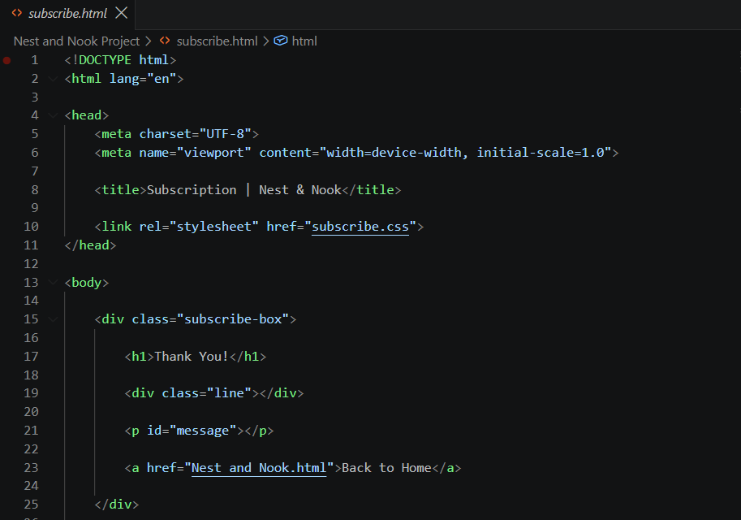

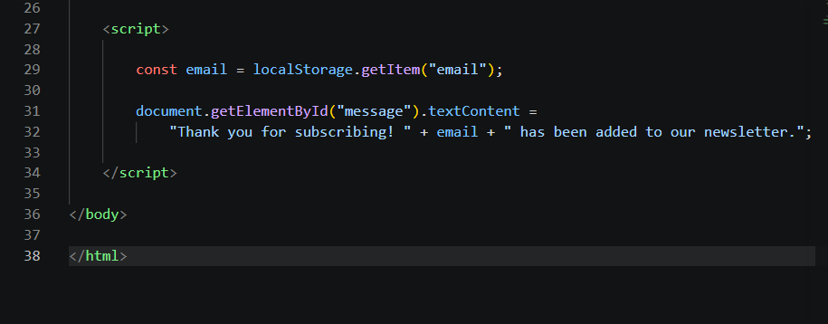

5. Challenges and limitation
One challenge was organizing many webpage elements into clear sections while keeping the structure easy to understand. Another challenge was connecting navigation links and different webpage components correctly.
Some limitations remain in the current project. Several footer and social media links are placeholders. The HTML also depends on the separate CSS and JavaScript files, so the complete styling and JavaScript behavior cannot be confirmed from the HTML file alone.
6. Conclusion and Discussion
Nest & Nook successfully demonstrates the design of a modern furniture online shop webpage. The project combines a header, hero section, featured products, room categories, newsletter area, and footer into one organized interface.
The project also provided practical experience in creating a webpage structure with HTML and connecting it with CSS and JavaScript. Overall, the project achieved its main objective of creating a simple and attractive furniture shopping webpage.
7. Future Work
- Adding more furniture products and product detail pages.
- Developing a complete shopping cart with quantity and total-price features.
- Improving the search and add product filtering by room, type, or price.
- Replacing placeholder links with working pages.
- Adding a complete checkout and secure payment system.
8. References
W3Schools – HTML
https://www.w3schools.com/html/
— Used as a reference for HTML structure and elements.
W3Schools – CSS
https://www.w3schools.com/css/
— Used as a reference for CSS styling and webpage design.
ChatGPT – OpenAI
https://chatgpt.com/
— Used as an assistance tool for understanding code, solving coding problems, and improving the webpage.
Font Awesome
https://fontawesome.com/icons
— Used as a source for icons such as Facebook, Instagram, Pinterest, home, and shopping cart icons.

9. Individual Contributions
Student 1: Tasmin Ara
Contribution: I was responsible for developing and organizing the main HTML structure of the Nest & Nook webpage. I worked on different parts of the webpage and made sure the sections were arranged properly and easy to understand. I also worked on half of the project report, helping to write and organize the information about our project. In addition, I helped find suitable pictures for the webpage and organized them so they could be used in the different sections of the website.
.
Student 2: Kobra Nasiri
Contribution: I was responsible for creating a separate html file for the Contact page. I also found and organized the pictures used for the furniture products and other sections of the webpage. In addition, I created the JavaScript code for the main Nest & Nook project to add interactive functionality. I also contributed to writing and organizing half of the project report.

Student 3: Khatira Akhlaqi
Contribution: I was responsible for creating the separate HTML for subscribe page and two CSS files for the Contact page and Subscribe section. I worked on designing and organizing these sections to make them clear and user-friendly. I also found and organized the product pictures used in the project.

